**CP PROJECT REPORT**

**STUDENT INFORMATION MANAGEMENT SYSTEM**

BY

SUHA SHAHID 02-134222-003

MOHAMMAD SOBAN 02-134222-010

MUHAMMAD SAAD KHAN 02-134222-086

|  |
| --- |
| **INTRODUCTION** |

This project is about student information management system. It uses C++ language and works and on various software like visual studio. The system used various functions and structures and stores data in text files. This system allows the user to easily access and manage saved details of various students and can also make changes to the data easily.

|  |
| --- |
| **OBJECTIVES** |

* To create a simple menu for student/teacher
* To let students view their saved details.
* To let teachers add, update, delete or search specific student’s details.
* To store student information safely in the text files for easy accessibility.
* To make a report of student’s academic details.

|  |
| --- |
| **INPUTS** |

* User can choose between student and teacher from the menu to use required option.
* User if chooses student then can view each student’s personal details by just searching for the id.
* User if chooses teacher option then can get welcomed by various options.
* User can then choose between adding, viewing, updating, searching and deleting student information.
* User can specifically search for any student by just typing their id.
* User can enter choices to manage student information.

|  |
| --- |
| **OUTPUTS** |

* A menu for the user.
* Options for the user to choose between student and teacher.
* Student details when specific student id is searched.
* Various options to insert, delete, view, update or search when teacher’s option is chosen.
* Let user either pick between adding details or adding marks.
* Enter all the required student details when asked.
* Enter all the required marks details when asked.
* Save the date and show it in separate text file.

|  |
| --- |
| **ALGORITHM** |

* Ask user to enter choice to view student aur teacher details.
* If user presses 1, ask them to view student details or marks.
* If user presses 2, show them 6 teacher related options.
* Show user to either insert details/marks, delete details/marks, update details/marks, search details/marks, view details/marks.
* Ask user to enter 1 or 2 to make changes to details or marks respectively.
* End task by pressing 6.

|  |
| --- |
| **FLOWCHART** |

|  |
| --- |
| **SOURCE CODE** |

#include<iostream>

#include<fstream>

#include<string>

using namespace std;

int i = 0;

struct stud {

int id;

string name;

string f_name;

string l_name;

string email;

string p_num;

int yob;

}stdt[20];

struct marks {

int eng;

int urdu;

int maths;

int science;

int computer;

long int tot;

float perce;

char grade;

}obj[20];

//for copied variables

struct temp {

int id2;

string name2;

string f_name2;

string l_name2;

string email2;

float marks2;

float percent2;

string p_num2;

int yob2;

int eng2;

int urdu2;

int maths2;

int science2;

int computer2;

char grade2;

}obj1[20];

int insertDetails();

int insertMarks();

int displayDetails();

int updateDetails();

int searchDetails();

int delDetails();

int filing();

int teacher();

int student();

int filing2();

void main()

{

char c;

int choice1;

do {

cout << "\t\t\t------Student Information Management System------" << endl;

cout << "\t\tPress 1 (For Teachers) " << endl;

cout << "\t\tPress 2 (For Students) " << endl;

cout << "\t\tEnter Your Choice: ";

cin >> choice1;

if (choice1 == 1)

{

teacher();

}

else if (choice1 == 2)

{

student();

}

else

{

cout << "\t\tInvalid Input" << endl;

}

cout << "\t\tPress y to continue or any key to exit: ";

cin >> c;

} while (c == 'y' || c == 'Y');

system("cls");

system("pause");

}

int teacher()

{

system("Cls");

int choice;

char cont;

do {

cout << "\t\t\t------Student Information Management System------" << endl;

cout << "\t\t\t\t------Teacher------" << endl;

cout << "\t\t\tPress 1 to Enter Student Details" << endl;

cout << "\t\t\tPress 2 to Update Student Details" << endl;

cout << "\t\t\tPress 3 to Delete Student Details" << endl;

cout << "\t\t\tPress 4 to Search Student Details" << endl;

cout << "\t\t\tPress 5 to Display Student Details" << endl;

cout << "\t\t\tPress 6 to Exit" << endl;

cout << "\t\t\tEnter Your Choice: ";

cin >> choice;

if (choice == 1)

{

system("Cls");

int choice2;

cout << "\t\t\t------Student Information Management System------" << endl;

cout << "\t\t\tPress 1 to insert Student Details " << endl;

cout << "\t\t\tPress 2 to insert Student Marks" << endl;

cout << "\t\t\tEnter Your Choice: ";

cin >> choice2;

if (choice2 == 1)

{

system("Cls");

insertDetails();

}

else if (choice2 == 2)

{

system("Cls");

insertMarks();

}

}

else if (choice == 2)

{

system("Cls");

updateDetails();

}

else if (choice == 3)

{

system("cls");

delDetails();

}

else if (choice == 4)

{

system("cls");

searchDetails();

}

else if (choice == 5)

{

system("cls");

displayDetails();

}

else if (choice == 6)

{

break;

}

cout << "\t\t\tDo You Want To Continue:";

cin >> cont;

} while (cont == 'y' || cont == 'Y');

system("cls");

return 0;

}

int student()

{

char c;

int choice3;

do {

cout << "\t\t\t\t------Student------" << endl;

cout << "\t\t\tViewing Your Details " << endl;

system("cls");

searchDetails();

cout << "\t\t\tPress y to contniue: ";

cin >> c;

} while (c == 'y' || c == 'Y');

return 0;

}

int insertDetails()

{

cout << "\t\t\t------Student Information Management System------" << endl;

cout << "\t\t\t\tEnter Student Details" << endl;

cout << "\t\t\tEnter student Id :";

cin >> stdt[i].id;

cout << "\t\t\tEnter student name: ";

getline(cin >> ws, stdt[i].name);

cout << "\t\t\tEnter student's Last Name: ";

getline(cin >> ws, stdt[i].l_name);

cout << "\t\t\tEnter student's Father Name: ";

getline(cin >> ws, stdt[i].f_name);

cout << "\t\t\tEnter student email: ";

getline(cin >> ws, stdt[i].email);

cout << "\t\t\tEnter student phone number: ";

getline(cin >> ws, stdt[i].p_num);

cout << "\t\t\tEnter student Year Of Birth: ";

cin >> stdt[i].yob;

i++;

filing();

filing2();

return 0;

}

int filing2() {

ofstream out2("shortlisted.txt", ios::out);

for (int j = 0; j < i; j++)

{

out2 << stdt[j].id << endl;

out2 << stdt[j].name << endl;

out2 << stdt[j].l_name << endl;

out2 << stdt[j].f_name << endl;

out2 << stdt[j].email << endl;

out2 << stdt[j].p_num << endl;

out2 << stdt[j].yob << endl;

out2 << obj[j].eng << endl;

out2 << obj[j].urdu << endl;

out2 << obj[j].maths << endl;

out2 << obj[j].science << endl;

out2 << obj[j].computer << endl;

out2 << obj[j].tot << endl;

out2 << obj[j].perce << endl;

out2 << obj[j].grade << endl;

}

return 0;

}

int filing()

{

ofstream out("studentData.txt", ios::out);

for (int j = 0; j < i; j++)

{

out << "\t\t\tStudent Id :" << stdt[j].id << endl;

out << "\t\t\tStudent name: " << stdt[j].name << endl;

out << "\t\t\tStudent Last Name: " << stdt[j].l_name << endl;

out << "\t\t\tStudent's Father Name: " << stdt[j].f_name << endl;

out << "\t\t\tstudent email: " << stdt[j].email << endl;

out << "\t\t\tStudent phone number: " << stdt[j].p_num << endl;

out << "\t\t\tStudent Year Of Birth: " << stdt[j].yob << endl;

out << "\t\t\tEnglish Marks: " << obj[j].eng << endl;

out << "\t\t\tUrdu Marks: " << obj[j].urdu << endl;

out << "\t\t\tMaths Marks: " << obj[j].maths << endl;

out << "\t\t\tScience Marks: " << obj[j].science << endl;

out << "\t\t\tComputer Marks: " << obj[j].computer << endl;

/*obj[j].tot = obj[j].eng + obj[j].urdu + obj[j].maths + obj[j].science + obj[j].computer;

obj[j].perce = (obj[j].tot * 100) / 250;*/

out << "\t\t\tTOTAL MARKS : " << obj[j].tot << " /250 " << endl;

out << "\t\t\tPERCENTAGE: " << obj[j].perce << endl;

out << "\t\t\tGRADE: " << obj[j].grade << endl;

}

return 0;

}

int insertMarks()

{

cout << "\t\t\t------Student Information Management System------" << endl;

int search_id;

cout << "\t\t\tEnter Student Id To Insert Marks: ";

cin >> search_id;

cout << "\t\t\t\tEnter Student's Marks" << endl;

for (int j = 0; j < i; j++)

{

if (search_id == stdt[j].id)

{

cout << "\t\t\tEnter Student's English Marks: ";

cin >> obj[j].eng;

cout << "\t\t\tEnter Student's Urdu Marks: ";

cin >> obj[j].urdu;

cout << "\t\t\tEnter Student's Maths Marks: ";

cin >> obj[j].maths;

cout << "\t\t\tEnter Student's Science Marks: ";

cin >> obj[j].science;

cout << "\t\t\tEnter Student's Computer Marks: ";

cin >> obj[j].computer;

obj[j].tot = obj[j].eng + obj[j].urdu + obj[j].maths + obj[j].science + obj[j].computer;

obj[j].perce = (obj[j].tot * 100) / 250;

if (obj[j].perce < 50)

{

obj[j].grade = 'F';

}

if (obj[j].perce > 50 && obj[j].perce < 60)

{

obj[j].grade = 'D';

}

if (obj[j].perce > 60 && obj[j].perce > 70)

{

obj[j].grade = 'C';

}

if (obj[j].perce > 70 && obj[j].perce >= 80)

{

obj[j].grade = 'B';

}

if (obj[j].perce > 80 && obj[j].perce > 100)

{

obj[j].grade = 'A';

}

}

}

filing();

filing2();

system("cls");

return 0;

}

int displayDetails()

{

ifstream in2("studentData.txt", ios::in);

string l;

while (in2.eof() == 0)

{

getline(in2, l);

cout << l << endl;

}

system("cls");

return 0;

}

int updateDetails()

{

cout << "\t\t\t------Student Information Management System------" << endl;

int id2;

cout << "\t\t\tEnter the id you want to update details of: ";

cin >> id2;

for (int k = 0; k < i; k++)

{

if (id2 == stdt[k].id)

{

cout << "\t\t\tStudent Id :" << stdt[k].id << endl;

cout << "\t\t\tStudent name: " << stdt[k].name << endl;

cout << "\t\t\tStudent Last Name: " << stdt[k].l_name << endl;

cout << "\t\t\tStudent's Father Name: " << stdt[k].f_name << endl;

cout << "\t\t\tstudent email: " << stdt[k].email << endl;

cout << "\t\t\tStudent phone number: " << stdt[k].p_num << endl;

cout << "\t\t\tStudent Year Of Birth: " << stdt[k].yob << endl;

cout << "\t\t\tEnglish Marks: " << obj[k].eng << " /50 " << endl;

cout << "\t\t\tUrdu Marks: " << obj[k].urdu << " /50 " << endl;

cout << "\t\t\tMaths Marks: " << obj[k].maths << " /50 " << endl;

cout << "\t\t\tScience Marks: " << obj[k].science << " /50 " << endl;

cout << "\t\t\tComputer Marks: " << obj[k].computer << " /50 " << endl;

cout << "\t\t\tTOTAL MARKS : " << obj[k].tot << " /250 " << endl;

cout << "\t\t\tPERCENTAGE: " << obj[k].perce << endl;

cout << "\t\t\tGRADE: " << obj[k].grade << endl;

int choice3;

cout << "\t\t\t------Student Information Management System------" << endl;

cout << "\t\t\tPress 1 for updating students details " << endl;

cout << "\t\t\tPress 2 for updating marks " << endl;

cout << "\t\t\tPress 3 for updating all details and marks " << endl;

cout << "\t\t\tEnter Your Choice: ";

cin >> choice3;

if (choice3 == 1)

{

system("cls");

cout << "\t\t\t------Student Information Management System------" << endl;

cout << "\t\t\t\tUpdating students details" << endl;

cout << "\t\t\tEnter new id: ";

cin >> stdt[k].id;

cout << "\t\t\tEnter new name: ";

cin >> stdt[k].name;

cout << "\t\t\tEnter new last name: ";

cin >> stdt[k].l_name;

cout << "\t\t\tEnter new Father name: ";

cin >> stdt[k].f_name;

cout << "\t\t\tEnter new Email: ";

cin >> stdt[k].email;

cout << "\t\t\tEnter new Phone number: ";

cin >> stdt[k].p_num;

cout << "\t\t\tEnter year of birth: ";

cin >> stdt[k].yob;

filing();

filing2();

system("cls");

}

if (choice3 == 2)

{

system("cls");

cout << "\t\t\t------Student Information Management System------" << endl;

cout << "\t\t\t\tUpdating students marks " << endl;

cout << "\t\t\tEnter the marks for English: ";

cin >> obj[k].eng;

cout << "\t\t\tEnter the marks for Urdu: ";

cin >> obj[k].urdu;

cout << "\t\t\tEnter the marks for Maths: ";

cin >> obj[k].maths;

cout << "\t\t\tEnter the marks for Science: ";

cin >> obj[k].science;

cout << "\t\t\tEnter the marks for Computer: ";

cin >> obj[k].computer;

obj[k].tot = obj[k].eng + obj[k].urdu + obj[k].maths + obj[k].science + obj[k].computer;

obj[k].perce = (obj[k].tot * 100) / 250;

cout << "\t\t\tTOTAL MARKS : " << obj[k].tot << " /250 " << endl;

cout << "\t\t\tPERCENTAGE: " << obj[k].perce << endl;

if (obj[k].perce > 50 && obj[k].perce < 60)

{

obj[k].grade = 'D';

}

if (obj[k].perce > 60 && obj[k].perce > 70)

{

obj[k].grade = 'C';

}

if (obj[k].perce > 70 && obj[k].perce >= 80)

{

obj[k].grade = 'B';

}

if (obj[k].perce > 80 && obj[k].perce > 100)

{

obj[k].grade = 'A';

}

cout << "\t\t\tPERCENTAGE: " << obj[k].grade << endl;

filing();

filing2();

system("cls");

}

if (choice3 == 3)

{

system("cls");

cout << "\t\t\t------Student Information Management System------" << endl;

cout << "\t\t\tEnter new id: ";

cin >> stdt[k].id;

cout << "\t\t\tEnter new name: ";

cin >> stdt[k].name;

cout << "\t\t\tEnter new last name: ";

cin >> stdt[k].l_name;

cout << "\t\t\tEnter new Father name: ";

cin >> stdt[k].f_name;

cout << "\t\t\tEnter new Email: ";

cin >> stdt[k].email;

cout << "\t\t\tEnter new Phone number: ";

cin >> stdt[k].p_num;

cout << "\t\t\tEnter year of birth: ";

cin >> stdt[k].yob;

cout << "\t\t\t\tUpdating students marks" << endl;

cout << "\t\t\tEnter the marks for English: ";

cin >> obj[k].eng;

cout << "\t\t\tEnter the marks for Urdu: ";

cin >> obj[k].urdu;

cout << "\t\t\tEnter the marks for Maths: ";

cin >> obj[k].maths;

cout << "\t\t\tEnter the marks for Science: ";

cin >> obj[k].science;

cout << "\t\t\tEnter the marks for Computer: ";

cin >> obj[k].computer;

obj[k].tot = obj[k].eng + obj[k].urdu + obj[k].maths + obj[k].science + obj[k].computer;

obj[k].perce = (obj[k].tot * 100) / 250;

cout << "\t\t\tTOTAL MARKS : " << obj[k].tot << " /250 " << endl;

cout << "\t\t\tPERCENTAGE: " << obj[k].perce << endl;

filing();

filing2();

}

}

}

return 0;

}

int searchDetails()

{

cout << "\t\t\t------Student Information Management System------" << endl;

int f = 0;

ifstream in("shortlisted.txt", ios::in);

while (in >> obj1[f].id2, in >> obj1[f].name2, in >> obj1[f].f_name2, in >> obj1[f].l_name2, in >> obj1[f].email2, in >> obj1[f].p_num2, in >> obj1[f].yob2, in >> obj1[f].eng2, in >> obj1[f].urdu2, in >> obj1[f].maths2, in >> obj1[f].science2, in >> obj1[f].computer2, in >> obj1[f].marks2, in >> obj1[f].percent2, in >> obj1[f].grade2)

{

f++;

}

for (int i = 0; i < f; i++)

{

cout << obj1[i].id2;

cout << obj1[i].name2;

}

int search_id;

cout << "\t\t\tEnter Id: ";

cin >> search_id;

for (int i = 0; i < f; i++)

{

if (search_id == obj1[i].id2)

{

cout << "\t\t\tStudent's Id is: " << obj1[i].id2 << endl;

cout << "\t\t\tStudent's First Name is: " << obj1[i].name2 << endl;

cout << "\t\t\tStudent's Last Name is : " << obj1[i].f_name2 << endl;

cout << "\t\t\tStudent's Father Name is : " << obj1[i].l_name2 << endl;

cout << "\t\t\tStudent's Email Address is : " << obj1[i].email2 << endl;

cout << "\t\t\tStudent's Phone Number is : " << obj1[i].p_num2 << endl;

cout << "\t\t\tStudent's Year Of Birth is : " << obj1[i].yob2 << endl;

cout << "\t\t\tStudent's Marks of English are : " << obj1[i].eng2 << endl;

cout << "\t\t\tStudent's Marks of Urdu are : " << obj1[i].urdu2 << endl;

cout << "\t\t\tStudent's Marks of Maths are : " << obj1[i].maths2 << endl;

cout << "\t\t\tStudent's Marks of Science are : " << obj1[i].science2 << endl;

cout << "\t\t\tStudent's Marks of Computer are : " << obj1[i].computer2 << endl;

cout << "\t\t\tTOTAL MARKS : " << obj1[i].marks2 << " /250 " << endl;

cout << "\t\t\tPERCENTAGE: " << obj1[i].percent2 << endl;

cout << "\t\t\tGRADE: " << obj1[i].grade2 << endl;

break;

}

else

{

cout << "\t\t\tInvalid Input";

}

}

return 0;

}

int delDetails()

{

cout << "\t\t\t------Student Information Management System------" << endl;

int temp;

cout << "\n\t\t\tEnter Id To Delete ";

cin >> temp;

for (int k = 0; k < i; k++)

{

if (temp == stdt[k].id)

{

cout << "\t\t\tStudent Id :" << stdt[k].id << endl;

cout << "\t\t\tStudent name: " << stdt[k].name << endl;

cout << "\t\t\tStudent Last Name: " << stdt[k].l_name << endl;

cout << "\t\t\tStudent's Father Name: " << stdt[k].f_name << endl;

cout << "\t\t\tStudent email: " << stdt[k].email << endl;

cout << "\t\t\tStudent phone number: " << stdt[k].p_num << endl;

cout << "\t\t\tStudent Year Of Birth: " << stdt[k].yob << endl;

cout << "\t\t\tEnglish Marks: " << obj[k].eng << endl;

cout << "\t\t\tUrdu Marks: " << obj[k].urdu << endl;

cout << "\t\t\tMaths Marks: " << obj[k].maths << endl;

cout << "\t\t\tScience Marks: " << obj[k].science << endl;

cout << "\t\t\tComputer Marks: " << obj[k].computer << endl;

cout << "\t\t\tTOTAL MARKS : " << obj[k].tot << " /250 " << endl;

cout << "\t\t\tPERCENTAGE: " << obj[k].perce << endl;

cout << "\t\t\tGRADE : " << obj[k].perce << endl;

int choice3;

cout << "\t\t\tPress 1 for deleting students details" << endl;

cout << "\t\t\tPress 2 to return to menu " << endl;

cout << "\t\t\tEnter Your Choice: ";

cin >> choice3;

if (choice3 == 1)

{

int found = 0;

for (int j = 0; j < i; j++)

{

if (temp == stdt[j].id) {

for (int k = j; k < i - 1; k++)

{

cout << "\t\t\tStudent Name Is: " << stdt[j].name;

stdt[k].id = stdt[k + 1].id;

stdt[k].name = stdt[k + 1].name;

stdt[k].l_name = stdt[k + 1].l_name;

stdt[k].f_name = stdt[k + 1].f_name;

stdt[k].email = stdt[k + 1].email;

stdt[k].f_name = stdt[k + 1].f_name;

stdt[k].email = stdt[k + 1].email;

stdt[k].p_num = stdt[k + 1].p_num;

stdt[k].yob = stdt[k + 1].yob;

obj[k].eng = obj[k + 1].eng;

obj[k].urdu = obj[k + 1].urdu;

obj[k].maths = obj[k + 1].maths;

obj[k].science = obj[k + 1].science;

obj[k].computer = obj[k + 1].computer;

obj[k].perce = obj[k + 1].tot;

obj[k].tot = obj[k + 1].perce;

obj[k].grade = obj[k + 1].grade;

}

i--;

filing();

filing2();

cout << "\t\t\tDeleted"<< endl;

found++;

break;

}

}

if (found == 0)

{

cout << endl << "\t\t\tInvalid" << endl;

}

}

if (choice3 == 2)

{

break;

}

}

}

return 0;

}

|  |
| --- |
| **SOME OUTPUTS** |

MENU:

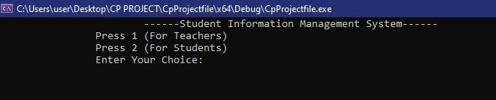

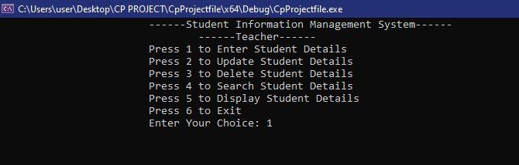

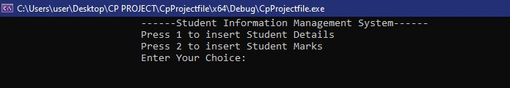

Entering Details:

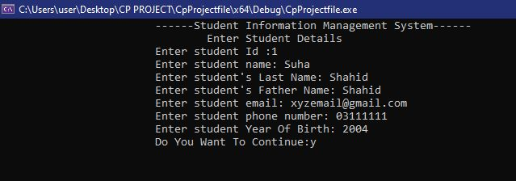

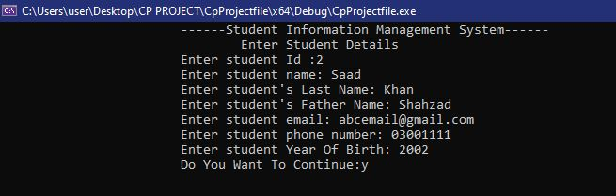

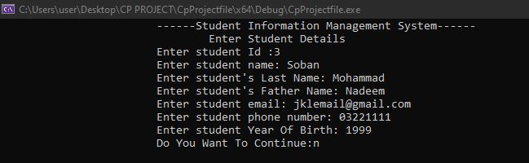

Updating Details:

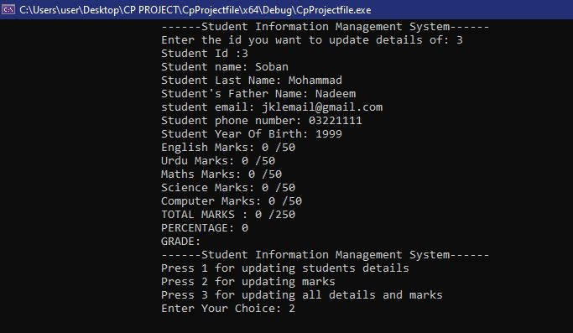

Deleting Details:

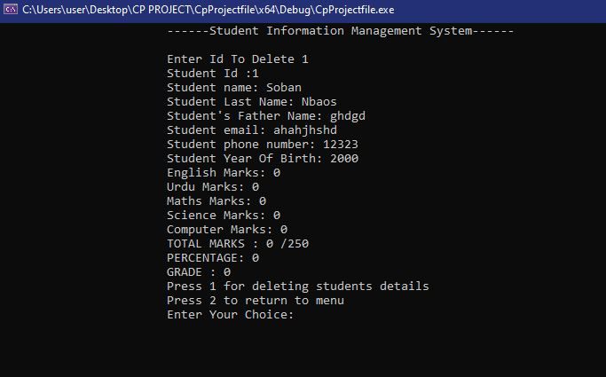

Searching Details:

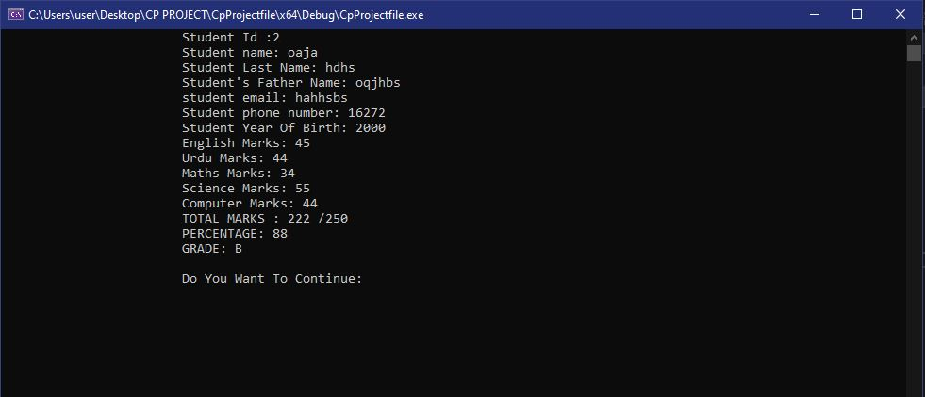

Displaying Details:

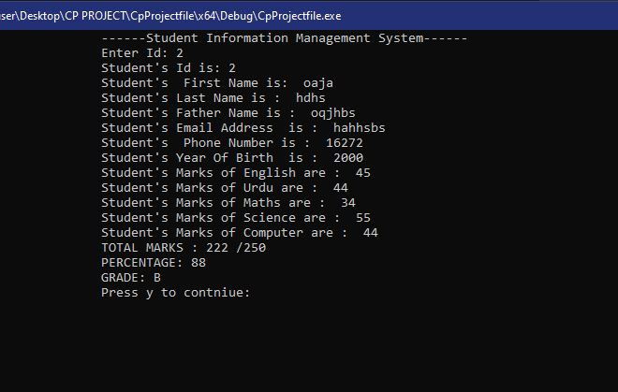

|  |
| --- |
| **SYSTEM TESTING** |

Each component of the program has been tested individually to prove the functionality of the project. The testing has been done by eliminating all the possible combinations of choices and testing the functions separately as well.

|  |
| --- |
| **CONCLUSION** |

The following results have been achieved after the completion of this project:

* All outputs displayed are appropriate with regards to the user selected choices.
* The program saves and generates the data accordingly to the given details.
* Includes an easy-to-use menu.
* It lets the student to view their details and marks.
* It lets teacher add student details and make changes accordingly.
* The data and be saved easily which keeps the records protected.